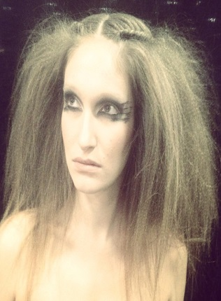
SABRINA BLACKBURN
EMC
(908) 907-4329
TheSAB3@msn.com
Height: 5'8" ● Weight: 128lb ● Eyes: Green
Bust: 34C ● Waist: 23" ● Hips: 35" ● Dress: 4 ● Pants: 3/5 ● Shoe: 7
THEATER (selected)
King Lear Cordelia Shakesperience
Productions
Radium Girls Grace Shakesperience
Productions
Macbeth Malcolm/witch/ Shakesperience
Lady Macduff Productions
And Then They Came For Me Mutti Northeast Children
Remembering The World of Anne Frank Theatre Company
Steel Magnolias(w/Karen Ziamba) u/s Shelby & Annelle Cape May Stage
Our Town Mrs. Webb Little Theatre Co
Eleemosynary Echo Cabaret Theatre
Sylvia Kate College Ave Players
12 Angry Men Juror 12 Cabaret Theatre
Cloud 9 Edward/Lin Cabaret Theatre
A Midsummer Night’s Dream Helena Eatontown Playhouse
Modeling
Print model Moroccanoil Hair Model Matrix
Runway Model Dore Fahsion Show Runway Model Loriis Fashion Show
Hair Model Wella Hair Model Sabastian Professional
Film
Delirium Nyx Do It Live Productions
Town & County Lanes Bowler Excelsior Wine & Spirits
Medical Industrial Patient Colt Neck Pediatrics
TRAINING
B.A. Rutgers University: Advance Acting: Chris O’Connor • Meisner Intensive:
Nitzan Mager
SPEACIAL SKILLS
Dialect: British (RP, Cockney, Yorkshire) • US (New York, Southern) • German • French
Sports: Softball • Soccer • Swimming • Surfing • Yoga • Pilates • Cycling
Stage Combat: (Hand to Hand)
Valid Driver’s License

