Michelle Rivera
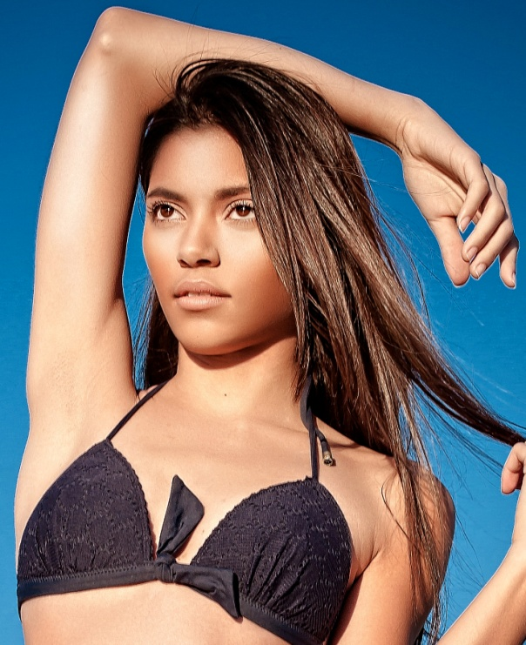
Michelleleerivera@gmail.com
Hair: Dark Brown Weight: 110
Eyes: Brown Height: 5’7

TELEVISION:
Glam Fairy Runway Model Style
Jerseylicious Print Model Style

MUSIC VIDEOS:
Shaliek - Ain’t Supposed To Cry Lead Directed: Epic DC
Diggy Simmons Ft. Trevor Jackson - My Girl Model Director: Garen Barsegian
Michelle Williams - Say Yes Extra Directed: Matthew A. Cherry
LLCOOLJ - The Hustler Model Directed: Benny Boom

MAGAZINES:
ECCENTRIC EDGE MAGAZINE Web Magazine The Premiere issue
TRAINING:
Modeling & Acting Barbizon School Of Modeling & Acting

Special Skills:
Dancing, Acting and Modeling.

