 | Teron TEXT Sorensen
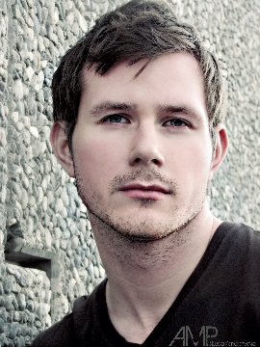 | Freelance Model  Stats:  Ht:6' 3" Eyes:Blue/Green  Wt:195 lbs Hair:Brown  Sizes:
  Shirt | Neck | Jacket | Waist | Inseam | Shoe
  XL-L | 17 | 42 L | 36 | 34 | 12

Training
Acting Courses:

Susan Batson Method: Acting Coach Nina Binder
Alchemy Of Acting Studios: 5 Week Improv Course
Film

Movies/Short Films:
Role: Project: Location:
British Victim YoDIE: An inspirational film Georgia
Rebel LumberJack The Hunger Games: Mockingjay Georgia
Employee #1 Gateway To Darkness Gateway, Alaska
Xander Corporate Elevator Anchorage, Alaska
Zombie Here With You Anchorage, Alaska
Model Year Off Anchorage, Alaska

Television
Shows:
Role: Project:
Walker/Zombie The Walking Dead, Season Four
Waitstaff Neccesary Roughness, Season Three

Commercials:

Project: Role: Studio: Location:
TGI Fridays: The Wild Guy Buzz Biz Studios Anchorage, Alaska
Modeling

Published Work:
Magazine: Issue:
Essere Magazine June Issue 2012

Fashion Shows:
Event: Location:
Bronner Bros. International 75th Annual Hair Show Atlanta, Georgia
Bronner Bros. 74th Annual Hair Show After Party Event Atlanta, Georgia
3rd Street Armory Fashion Show Atlanta, Georgia
MOD Factory Fashion Show Anchorage, Alaska
Nunez Clothing Fashion Show Anchorage, Alaska

