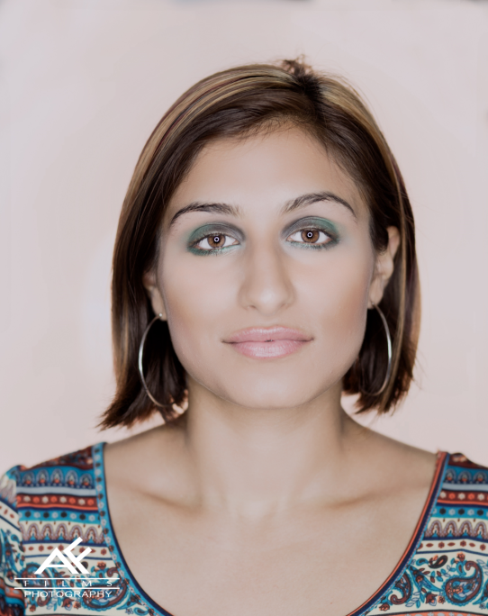
Ayanna Mangiaruga
Profile
I’m ambitious, have a fantastic work ethic, and fun personality. I’m looking to work in a professional environment where I can use my talents and skills.
Measurements: 34-26-36
Height: 5’2
Weight:115 lbs
Promotional/Marketing Experience
Type | Role | Client | Event Name | Dates
Charity Event | Brand Ambassador | Seal FSW Family Foundation | Charity Auction | 9/10/2015
Trade Show | Brand Ambassador | Powerteam International | Small Business Expo | 6/5/2015
Trade Show | Brand Ambassador | Salesforce | Salesforce World Tour | 6/15-  6/15
Trade Show | Brand Ambassador | India Handcrafts Inc | Ny Now | 8/12/2015-8/2015
Trade Show | Booth Hostess | Valgosa | Fancy Foods | 6/28/15-6/30/15
Mall Marketing | Brand Ambassador | Silkn’Smooth | Kohl’s Silkn’Smooth | 3/18/2015
Mall Marketing | Brand Ambassador | Express | 12/24 Express | 12/24/2015
Street Team | Brand Ambassador | King Digital Ent. | Alphabetty TSQ | 6/13/2015
Street Team | Brand Ambassador | iFrance | iFrance Run 2015 | 8/29/2015
Event Marketing | Brand Ambassador | Emblem Health | Farmer’s Market | 6/2015-Present
Event Marketing | Brand Ambassador | Emblem Health | Signature Events | 6/2015-Present
Event Marketing | Airport Greeter | Envision Experience | Envision Exp.JFK | 7/25/2015
In Store Demo | Brand Ambassador | Mr.Singh’s | In Store Demo | 2/2015-Present

