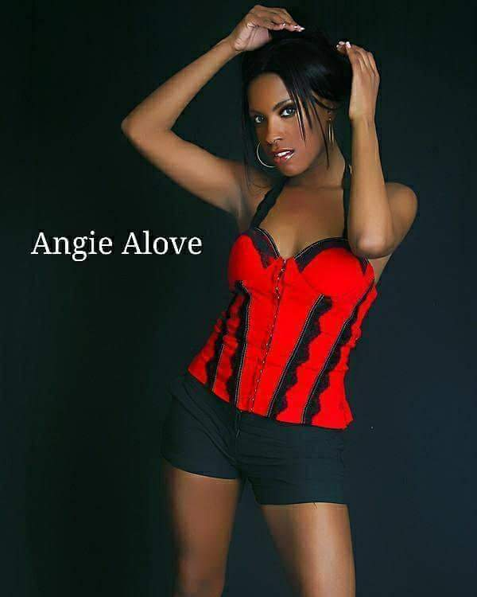
Table of Contents

Chapter (1)……. Artist Bio’s
Chapter (2)……. Pictures
Chapter (3)……. Networking Information
Chapter (4)……. Credits of Production
Chapter (5)……. Mechanical Beats Production Info.

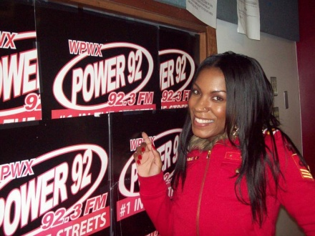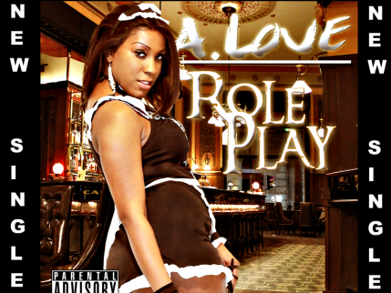

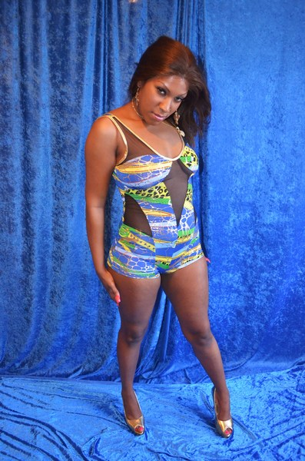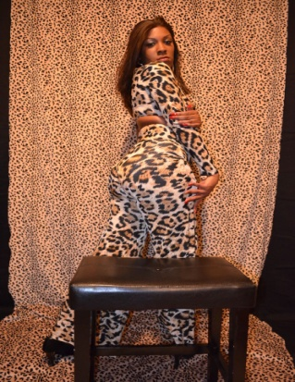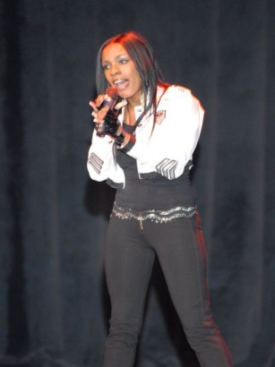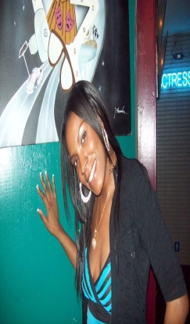

When the world says its ready for the next Super Star she will be ready.

Chapter (1) Artist Bio’s


Angie A-Love
Registered As: Artist, Writer, Co- Producer
Location: Chicago, Illinois
Official Member: ASCAP Member 2017
Publishing Company: A. Love Publishing
Production Company: Mechanical Beats Production 5- years.
No. # of Year's Writing Music: 15-years Genres: Urban Pop, R&B, Hip-Hop and Rap

Introduction to my Bio: A. Love is one of Chicago’s up and coming artists, Model, Songwriter, influenced by some of some the industry’s biggest, brightest and most talented singers most notably the late Aaliyah and the megastar Beyoncé, Lady Gaga, and Mariah Carey A. Love’s writing style brings a new creativeness to music. Combined with a unique voice, she delivers a message in her music people can relate to. Growing up on the southeast side of Chicago, Illinois A. Love has proved to herself as others have described her performances as one of the most exhilarating Artists in the Chicago land area to date. Honing a distinctive originality at a variety of talent shows, competitions, including the Royce Glamour television show, The All Stars, the Legendary Regal Theater, The genesis convention center in Gary Indiana, Redemption theater, performances and concerts in Chicago park districts, from performance at parker elementary school, signing autographs etc., being quest on true star radio, as well intellectual radio and power 92.3, MMWG Awards, UIC Forum, From open Mic’s, clubs etc. in and out of the Chicago land area. A. Love’s performances have been quite exciting. She works hard, delivering the most interesting songs the music industry wants to hear.
With the Production of Chicago’s very own super producers from Mechanical Beats Production, she has grown from girl to woman and continues striving to be the best at everything she does. This artist has something different that many seem to lack in the industry today, Originality. She’s her own artist with tailored made songs to go along with her style of singing. Alove has proven that not every artist has to settle for just a simple beat. Find a beat that fits and rely on your production team to bring it to life. You are only as good as your last hit.

Personal Achievements
- Sync Licensing and Mastering deal through Culture Shock Video LLC
- Regular rotation of songs played on Power 92.3 with in the last 4-years
- Songs played in rotation on ITL radio, I-Heart Radio & UBM Internet radio & Power 92.3
- Chicago Land top Nominated Angie Alove
- BMI Artist sign up in order to collect Musical royalties of music and performances
- Modeling gigs for Chicago top artist named Angie Alove
- Artist magazine spreads Brilliant, Barrio, Escapade, Pulse, Dymes, Belief & Motive
- Nominated for community spirit awards
- Artists booked on a 15-City School tour in sponsor of Demi Lobo from 107.5 WGCI
- Part of Latina Moore, Love Nasty Tour in part of 107.5 WGCI Summer Jam.
- Leased a song called (I do This ) with Michael Block founder of Culture Shock Video

Radio-Internet Interviews
- Interview at Intellectual Radio
- Interview at UBM internet Radio
- Interview at Power 92.3 Radio Station by Chicago’s very own Sean Dale Huntly
Magazine Interviews
- Brilliant Magazine
- Barrio Magazine
- Escapade Magazine
- Pulse Magazine
- Dyme’s Magazine
- Belief Magazine
- Motive Magazine
- Chicago Defender
- Chicago Sun-Times
Opening up for Chicago Land Artists
- Opening up for Chicago’s very own D-low the Bopp King
- Opening up for Yemi Marie
Videos under Production
- I don’t think your ready
- Go Viral
- Roll Play
- Think with Ya’ brain
- Got it Girl

Chapter (2) Pictures

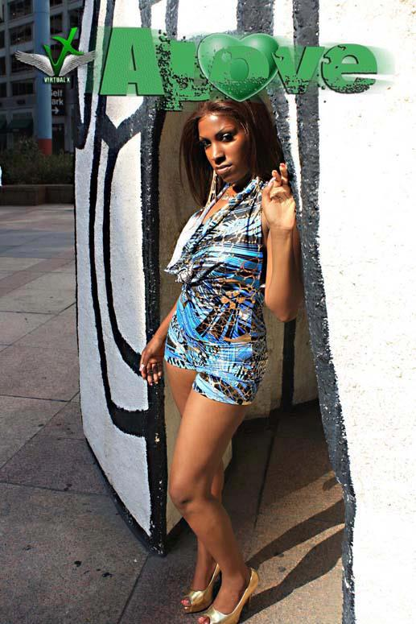
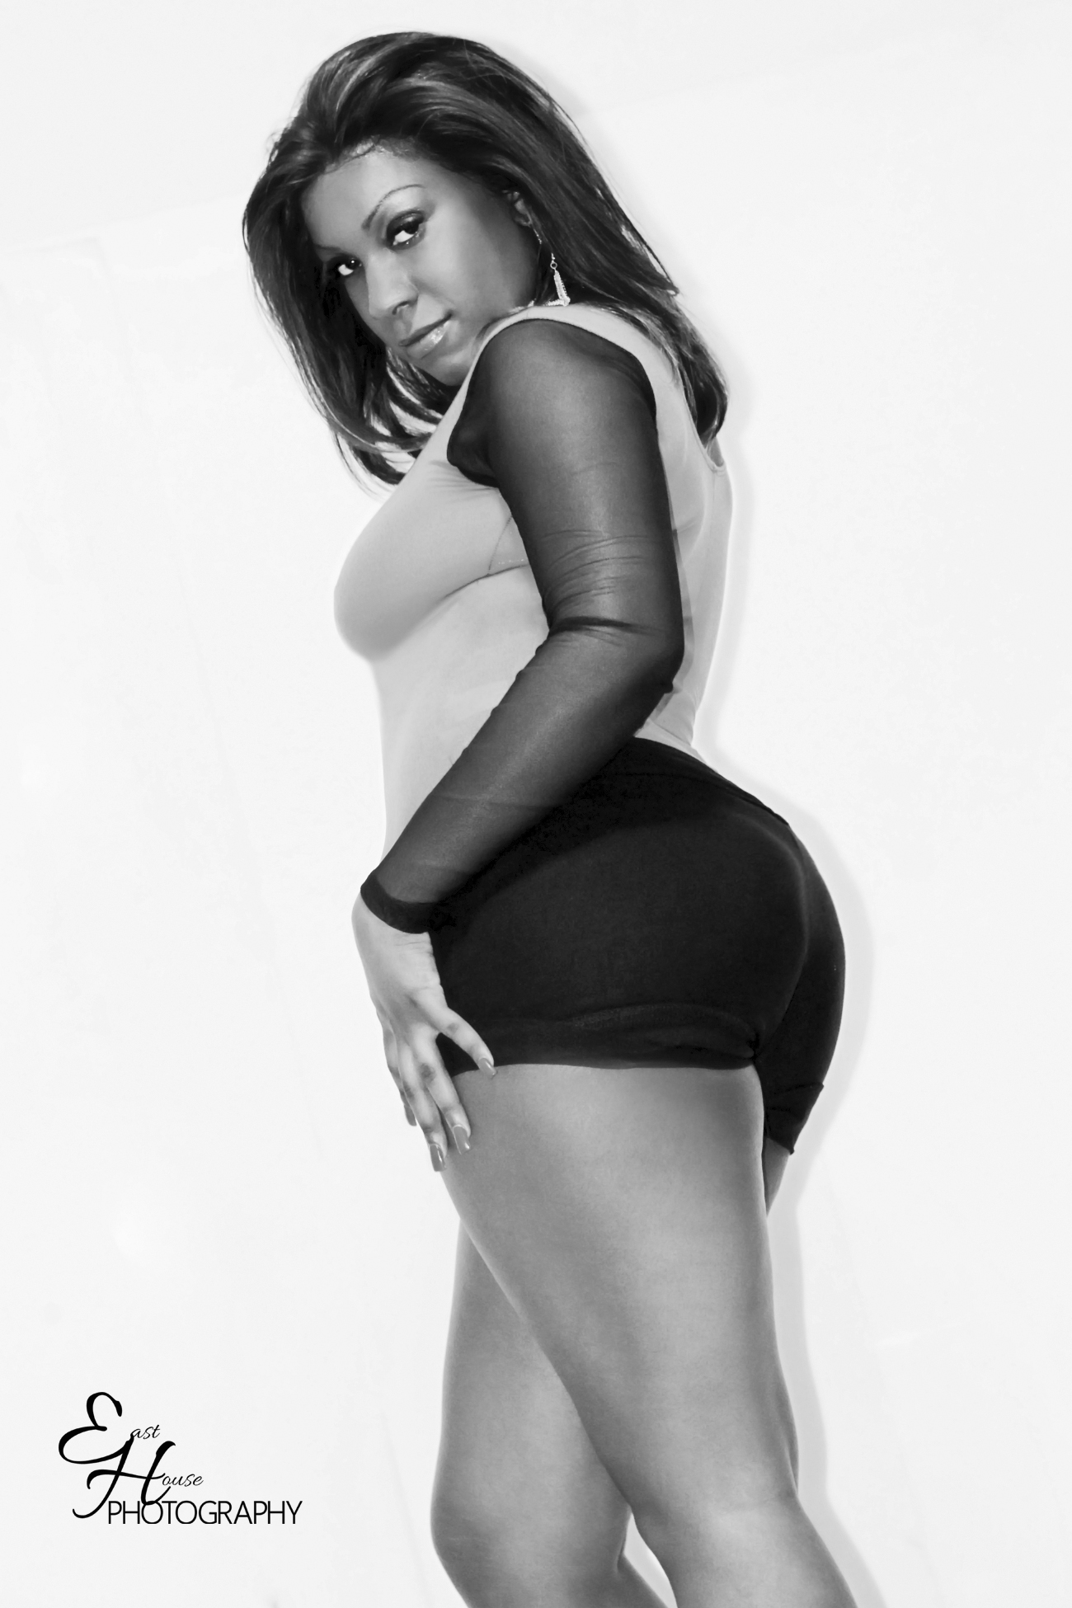



Chapter (3)
Networking Information

Networking Information

- http://www.Reverbnation.com/angiealove
- Twitter@The RealAlove
- FaceBook @The RealAlove
_________________________________________________

http://www.youtube.com/watch?v=rzT7LCTH6Xw

A.LOVE MMWG AWARDS PERFORMANCE

http://www.youtube.com/watch?NR=1&feature=endscreen&v=dnyCIgk25Kw

A.LOVE PERFORMANCE AT THE CHICAGO HEIGHTS FESTIVAL

http://www.youtube.com/watch?v=wX4uAI6fsQg

A.LOVE PERFORMANCE AT THE GOODTIME ENTERTAINMENT CENTER IN B

http://www.youtube.com/watch?v=xjM5ecRCooE

A LOVE MMWG AWARDS AT THE UIC FOURM BACK STAGE AND SHOW

http://www.youtube.com/watch?v=2aN4RL8MF1Y

ROLE PLAY PROMO SLIDE SHOW

http://www.youtube.com/watch?v=UYOa4Lj_1JU

A. LOVE ROLE PLAY BEHIND THE SCENES SHOT BY @DMMGFILMS

http://www.youtube.com/watch?v=9nEp4jWnB-s
GOT IT GIRL VIDEO

http://www.youtube.com/watch?v=BpJnFSVN2F0
Performing the her Single “ Dime Piece”

Chapter (4)
Credits of Production



Slow Motion
Produced By: Cederic Rodgers for Mechanical Beats Production, LLC. Co-Produced By: A-Love & Orlando Rodgers Written and Arranged By: A-Love
All Vocals & Back Ground By: A-Love Recorded At: Luella Sound Studio
Copyrights: 2017, ASCAP ADMIN.
Mixed & Mastered By: Orland Rodgers & Cederic Rodgers All Instruments Programming By: Cederic Rodgers

Fighting This Battle
Produced By: Cederic Rodgers for Mechanical Beats Production, LLC. Co-Produced By: A-Love Written and Arranged By: A-Love
All Vocals & Back Ground By: A-Love
Recorded At: Luella Sound Studio
Copyrights: 2017, ASCAP ADMIN.
Mixed & Mastered By: Orland Rodgers & Cederic Rodgers All Instruments Programming By: Cederic Rodgers

This Time
Produced By: Cederic Rodgers for Mechanical Beats Production LLC
Co-Produced By: A.Love
Written and Arranged By: A.Love
All Vocals & Back Ground By: A-Love Recorded At: Luella Sound Studio
Copyrights: 2017, ASCAP ADMIN.
Mixed & Mastered By: Orlando Rodgers & Cederic Rodgers
All Instruments Programming By: Cederic Rodgers
Forever
Produced By: Cederic Rodgers for Mechanical Beats Production LLC
Co-Produced By: A.Love
Written and Arranged By: A.Love
All Vocals & Back Ground By: A-Love Recorded At: Luella Sound Studio
Copyrights: 2017, ASCAP ADMIN.
Mixed & Mastered By: Orlando Rodgers & Cederic Rodgers
All Instruments Programming By: Cederic Rodgers

Chapter (5)
Mechanical Beats Production Info.

Cederic & Orlando Rodgers
Mechanical Beats Production

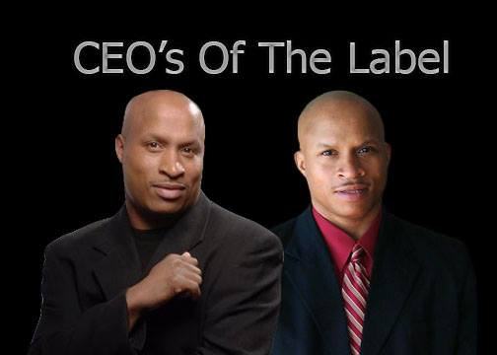
Mechanical Beats Productions has been founded and ran by both twin brothers named Cederic and Orlando Rodgers. Both brothers are veterans of independent music management and studio production. Their dreams of starting up a successful company were to have the opportunity to help others while they continued to pursue their dreams of making it one day into the music business. Slow success to minor success has been there story over the last past few years but, finding almost every way to feed financially off the industry has made them a small town success. They have produced for some of Chicago’s hottest up and coming young acts and have made many contributions revolving around there goals and pertaining to music. These brothers realized that they not only have something so unique but, they are destined to show Chicago the type of music production they were able to compete with.
As there style grew over the past few years these two brothers were able to transform music into money based of the type of style they mastered along the way. Mechanical Beats Production had a name which started from the sound of how the music was created. There sound was sort of the thing, these new aged artists were seeking and felt it was only important to give artists in the Chicago land and outside of Illinois that new sound that many can relate and jam too. They were well on their way with something so catchy and superb. Given the fact that these two brothers from the streets of Chicago has not only made there sound a house hold hit, but these guys really know there business as well. Once asked if they enjoyed creating music the both answered, not as much as we endure creating business behind the beats. 95% business and 5% music. Our motto has always been strong while trying to ring in them newly found rap artist here in our very own home town. Stop using beats for help and let us help the beats!

