Begine White-Klein

TV/Film:
Sanctified Rhonda Kings Productions
Late Night With Conan Featured NBC
Jack’s Big Word Musician Nickelodeon
Inside Edition Runway Model Warner Brothers

Theater/Stage:
The Nacirema Society Janet Logan Firestone Schools
Ghost the Musical Oda Mae Brown Firestone Schools
School House Rock Ensemble Akron Civic Theatre
The Little Mermaid Windward Firestone Schools
I Think You Think I Love You Branwyn Firestone Schools

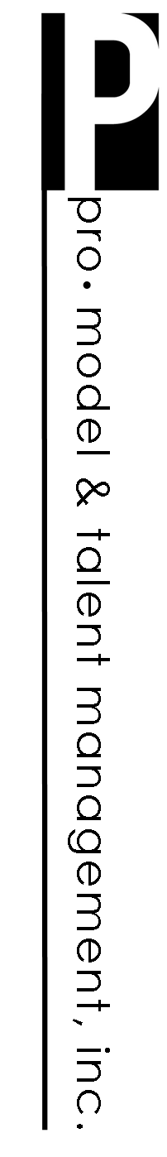
Training:
Audition Technique David Gray Los Angeles, CA
Uta Hagen’s Techniques Aubrey Caldwell M.F.A Akron, OH
Booking an Audition Logan Bartholomew Akron, OH
Improv For The Working Actor Ellen Rooney, Ph.D Akron, OH
Advanced Acting Techniques Al Onorato Los Angeles, CA
Audition Techniques Terry Cranendonk M.F. Akron, OH
Acting for Camera Aubrey Caldwell M.F.A. Akron, OH
Cold Reading James Madio Akron, OH
TV Commercial Maryann Nagel B.A. Akron, OH
Improv Leilani Barrett Akron, OH
Monologues Terry Cranendonk M.F. Akron, OH
Script Breakdown Aubrey Caldwell M.F.A. Akron, OH
Audition Readiness Jean Zarzour Akron, OH
Acting 101 Mark Zimmerman Akron, OH
Voice Chad Pittman 3 years
Voiceover Aubrey Caldwell M.F.A. Akron, OH

Special Skills: Spanish (conversational), singing (alto), running (cross country), drums (bass, marching band), color guard, jump rope, swimming, biking, accent (Southern)

