A M B E R L Y N N

SKILLS
Spokesmodel, Event Manager, print, film, sales/lead gen, advanced tech skills, teleprompter, atmosphere model, presenting/announcer

BRANDS REPRESENTED
Absolut Vodka, Adidas, Advil, Allstate Insurance, American Honey, Apple, Axe, Barefoot Wines, Bacardi, Best-Buy, Bing, Blu E-Cigs, Bluemoon Beer, Bridgestone, Budweiser, Bud Light, Cadillac, Canon, Chevrolet, Citi Bank, Coca-Cola, Eckrich Meats, Eppa Wines, Fireball Whiskey, Ford, Gamefly, Geico Insurance, Grey Goose, Hart and Huntington Clothing, Heineken, Herbalife, Honda, Jagermeister, Jameson, Jim Beam, Kahlua, Kellogs, Lift Master, L'Oreal, Malibu Rum, MARS Co, Maybelline, Mentos, Microsoft, Miller, Mobil-On The Run, Moskato, Nascar, New Amsterdam Vodka, Patron, Pepsi, PGA, Polk Audio, Powerade, Riunite Wines, Rockstar Energy, Scott’s Lawncare, Tanquery, TD Bank, Twisted Tea, US Bank, Wal-Mart, Wild Turkey, Yellowtail Wines, Zing Vodka, and many others.

HELLO THERE!
I am a spirited, intelligent and reliable spokesmodel specializing in promotional events, team leadership, sales, lead generation, and on-camera talent. If you’re seeking brains and beauty, I’m your girl!
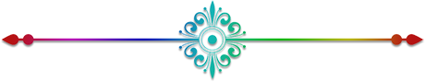
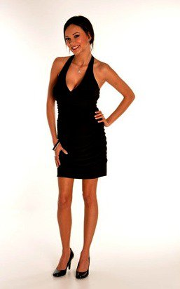
PRINT AND FILM
* American Honey Bourbon: Calendar, Billboard, and TV Commercial
* 105.7 The Point Eye Candy
* Inside STL - Girl Next Door
* University of Missouri – STL

EVENTS & TRADESHOWS
* Miami Ultra Music Festival
* North American Bitcoin Conference
* Miami Boat Show 2018
* Art Basel 2017 & ‘18
* SOBE Wine & Food Festival
* Miami Auto Show 2017
* Miami Bridal Show ‘16 & ‘17
* Ford - Model at the Races
* Daytona Beach Bike Week
* NASCAR - Daytona 500
* Turkey Rod Run Auto Show - Daytona Beach
* Biketoberfest -Daytona Beach
* Bonnaroo, Manchester, TN
* Tough Mudder Event Staff Manager - Chicago, IL
* Beer, Bourbon, and BBQ Festival - Nashville, TN
* Kid Rock Rebel Soul Tour/Jim Beam
* MLB Staff Manager – August 2013
* Maroon 5 Honda Civic Tour
* Whiskey in the Winter – St. Louis, MO
* LOUFest – St. Louis, MO
* Mars M&M Tradeshow – St. Louis, MO
* Warped Tour – St. Louis
* Budweiser Made in America Tour – St. Louis
* Race for the Cure – St. Louis
* Microsoft Grand Opening – St. Louis Galleria
* Bing It On Challenge
*Chevrolet Blues Week Festival – St. Louis
* Chelsea Football Club – St. Louis
* Rockstar Energy Motocross
* Bud Light Mardi Gras Team

