Amara Jade Sanchez
229 Dawn Ct. Kissimmee FL, 34743
Cell: 646-371-0652
Amarajadexo@gmail.com
Education:
- Osceola Virtual School (Class of 2016)
- American College for Medical Careers (Class of 2018)
Student Ambassador (President)
Experience:
- Phantom Fireworks Seasonal Sales Associate July 2015- July 2017
The position is for the week of Fourth of July and New Years
Duties included: Customer Service, Cashier, and Stocking
- Nautica at the International Premium Outlets
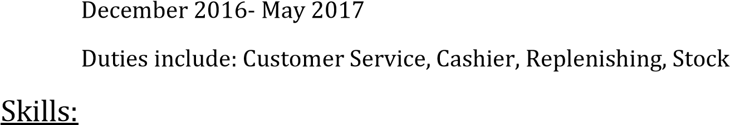
- Bilingual Knowledge of POS system
• | Vital Signs | Phlebotomy Injections
• | Patient Positions | Insurance EHR/EMR
• | Patient Education | Interpersonal Communications
• | ECG | Urinalysis Reception
• | ICD/CPT Coding | Office Finance Charting
• | Billing | Pediatric Vital Signs Filing
• | Typing 50 WPM | Medical Terminology

- CMA
- OSHA
- HIPAA
- CPR/BLS
