Lily Shia
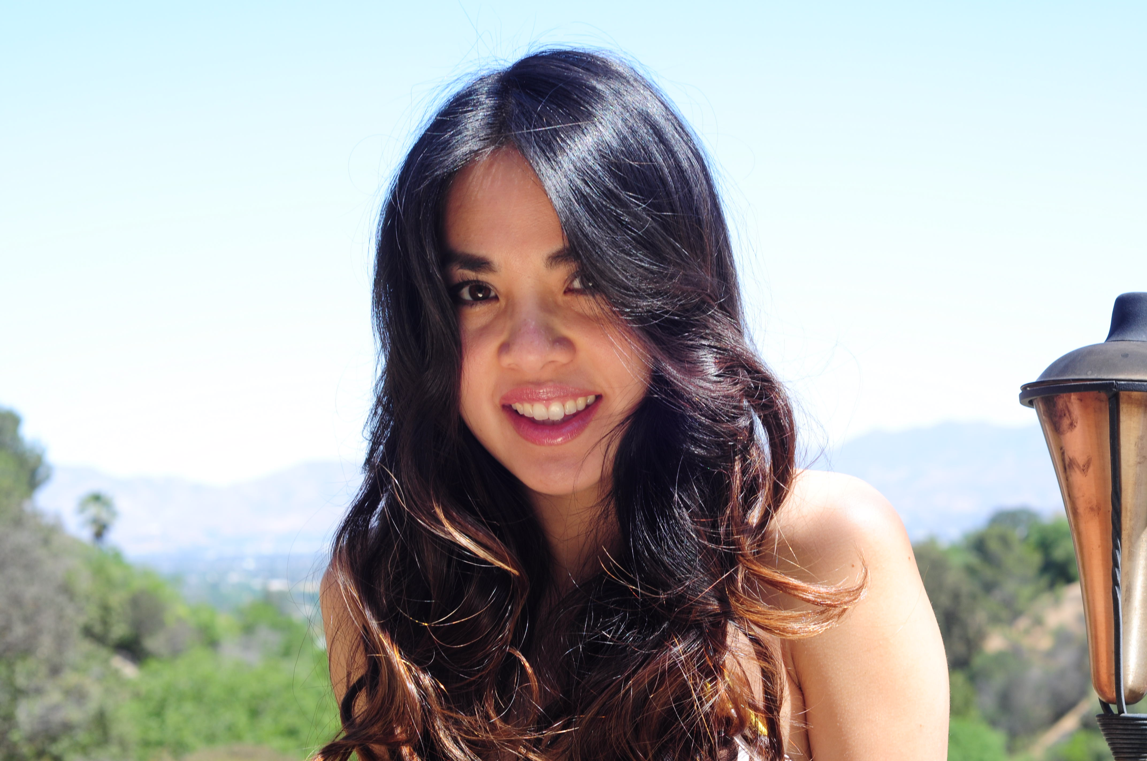

Ethnicity | Eurasian, Ambiguous | Measurements | 30D-25-34, size 0
Phone | 310-800-2809 | Hair/Eyes | Brown/Brown
Email | babyfarouj@yahoo.com | Weight/Height | 95 lbs/5’2”

Onscreen
Judge Junior “Don’t Dog Me” | Defendant | AJ/Broadcast West
Children’s Instit. “Toddlers Explore” | Mom | Holly Shapira/Picture Alternatives
COLCOA Academy Award directors | Correspondent | Carlos Zeron/CPC News Today
Kelly’s Hollywood premiere | Correspondent | Carlos Zeron/CPC News Today
Academy Awards viewing | Correspondent | Carlos Zeron/CPC News Today
Paging Dr. Andy show | Mom | Tera/T Group Productions
Norwegian Black Metal film | Club goer in blue dress | Evan Weinerman/Wondria Films, LLC
Mockumentary | Biker | Stephen Koenig/
Hillary Clinton campaign spoof | Mom | Adrian Anchodo/
Anti-smoking campaign | Mom | Petter Tangmyr/Beast of Sweden
Board Game commercial | Friend | Allen Wolf/Morning Star Pictures
LUVS “Awesome Travel Hacks” | Mom | Jesse Burton/Buzzfeed
Coca Cola (RED) commercial | Mom | Sven Shelgren/RCR, Inc.
Max Amini promo commercial | Mom | Max Amini/Abstraction Media Inc
AT&T Cloud technology commercial | Mom | William J. Saunders/Old City Entertain.
Pampers: Becoming Mommy | Self | Pampers Channel
Ally MacKay on Rosie Pope | Clothes model | KTLA Channel 5 News
“Undeniable” music video | Opening beach bunny | Treacherous Records
Circle of Bosses promo video | Opening receptionist | Treacherous Records

Print
Model | “You Are Beautiful” project by Corinne Rice
Product model | Headletics
Stock photos | Tiny Print Photos
Stock photos | Desirable Photos
Product model | Bun Maternity
Stock photos | Seth Lower Photography
Stock photos | Sam Diephuis Photography
Stock photos | Triple Threat Photography

Hair Modeling
Editorial | Stylist: Michael Haas (Salon Platinum Black)
Vidal Sassoon Top Artist | Stylist: Stephen Moody (Los Angeles)
Pink Wig Girl Mascot spokesperson | Blo Blow Dry Bar (Beverly Hills)
Wella P&G Top Artist | Stylists: Dana & Franco (LA Studio)
Schwarzkopf Annual Symposium  ISSE show | Stylists: Brian & Nicole (Privé Salon)  BaByliss

