Daniel Rivera
Non-Union

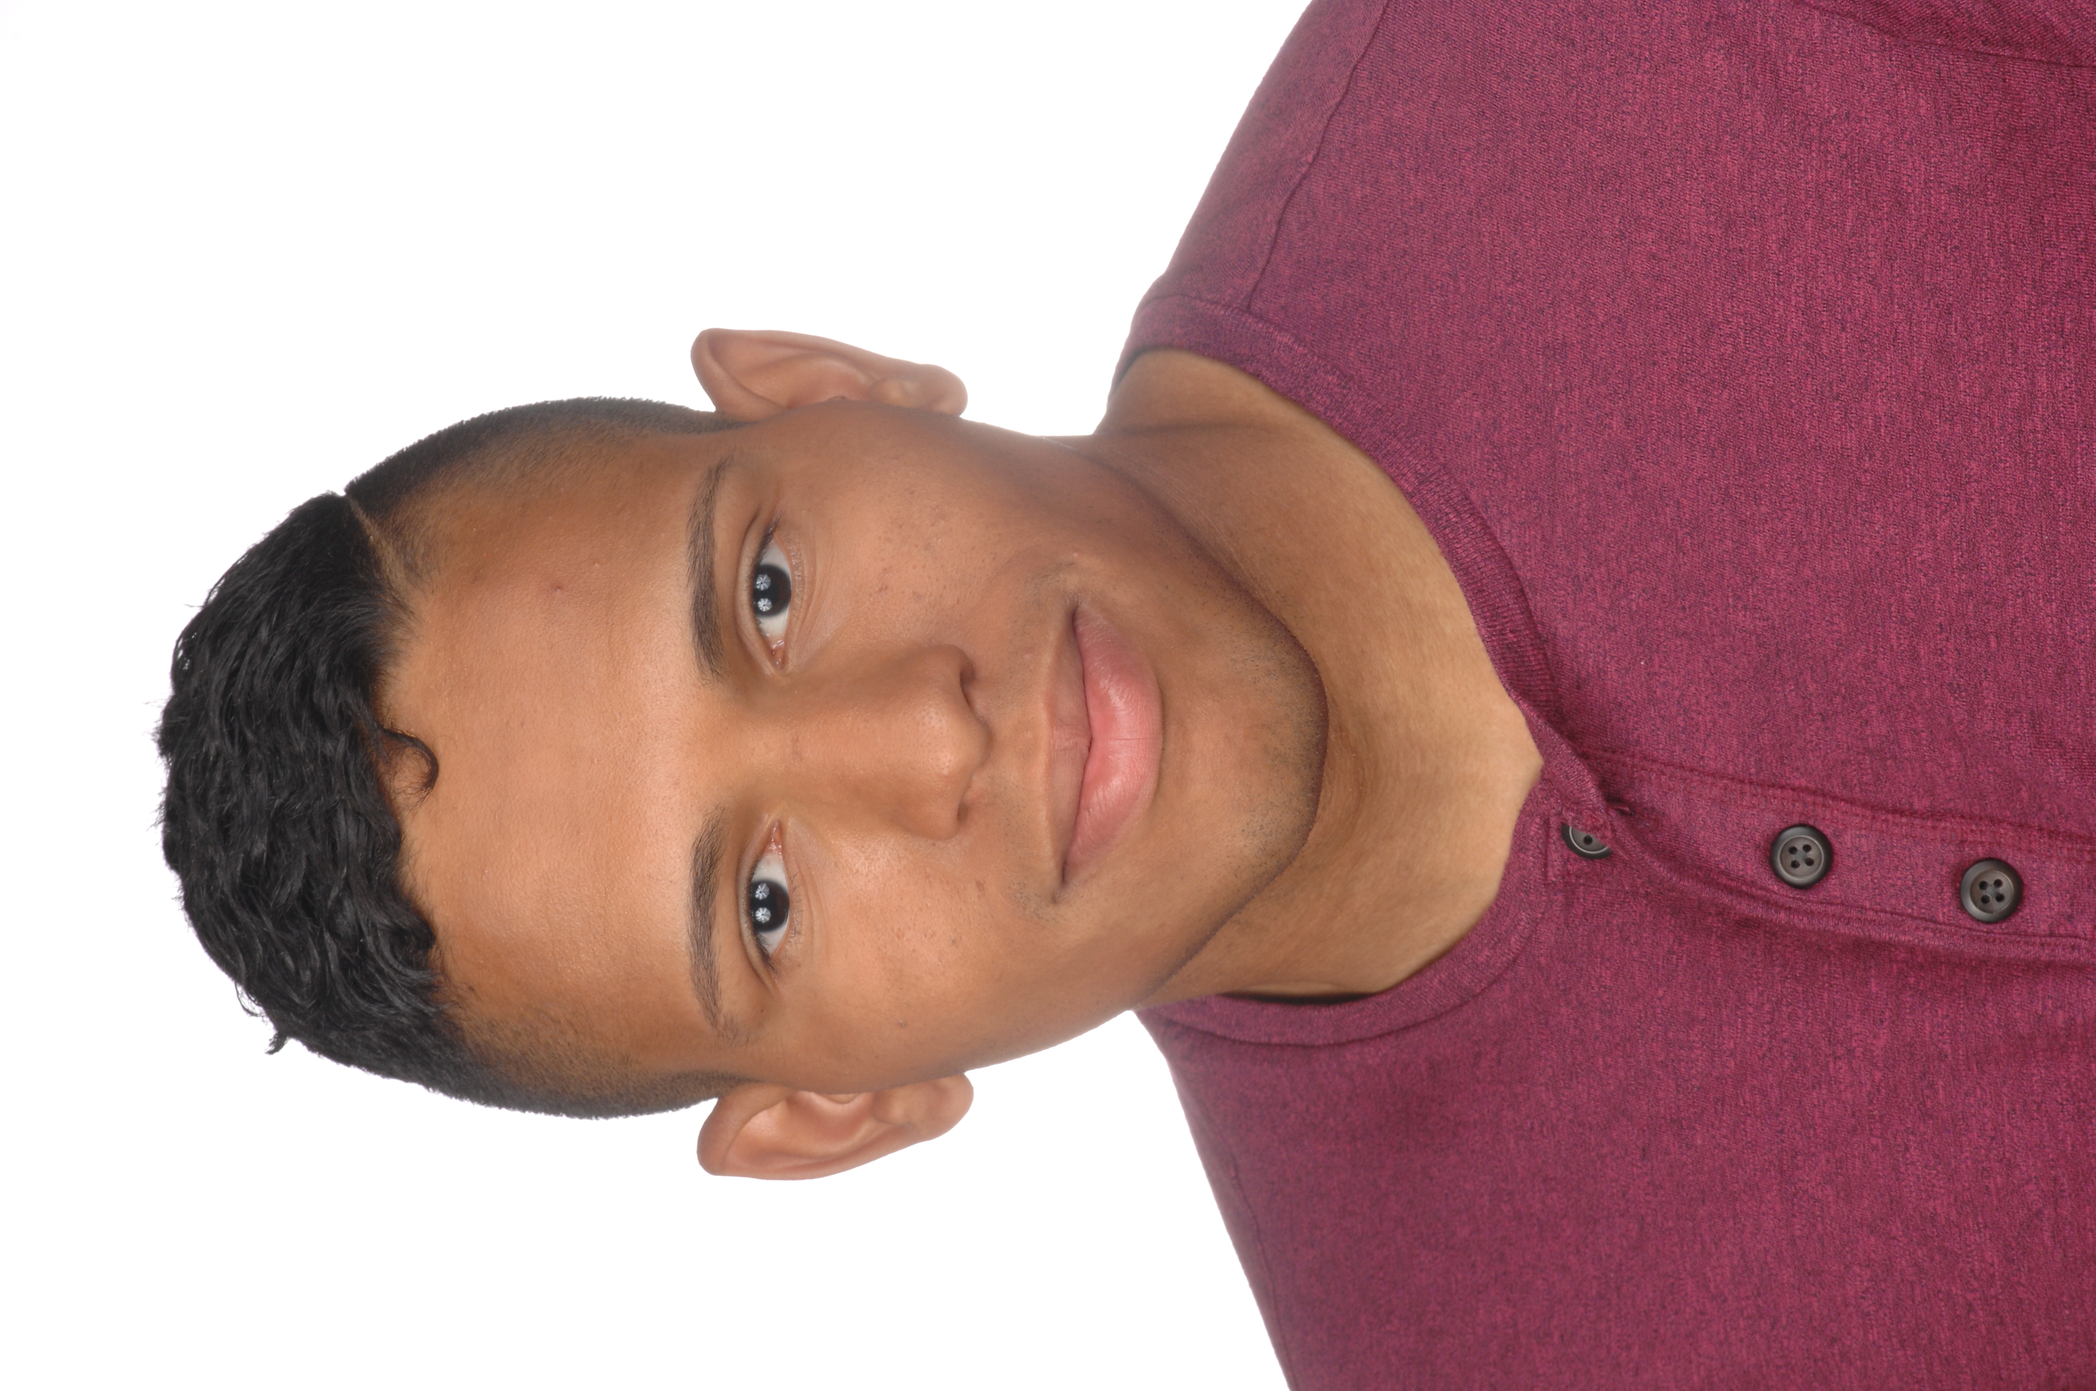
Phone: 484-426-0931
Email: DanielR23k@Gmail.com
Height 5’11 Weight 165
Age Range: 18-30 Hair: Black
Neck: 16 Eyes: Brown
Chest: 39 Suit: 40R
Waist: 30 Inseam: 32
Shirt: 15 Shoes: 9.5

Training
John Casablanca
Commercial – Bill Johnson
Improv – Damien Colletti
Modeling – Dwayne Dunlevy
Monologue – Roland Holvey
Special Skills
Badminton, Basketball, Billiard, Bowling, Boxing, Combat lifesaving, Drawing, Driving, Football, Gun handling, Jumping, Military, Repelling, Running, Swimming, Tennis, Track and field, Volleyball, Weight lifting, U.S. Army Veteran
Languages
English and Spanish

