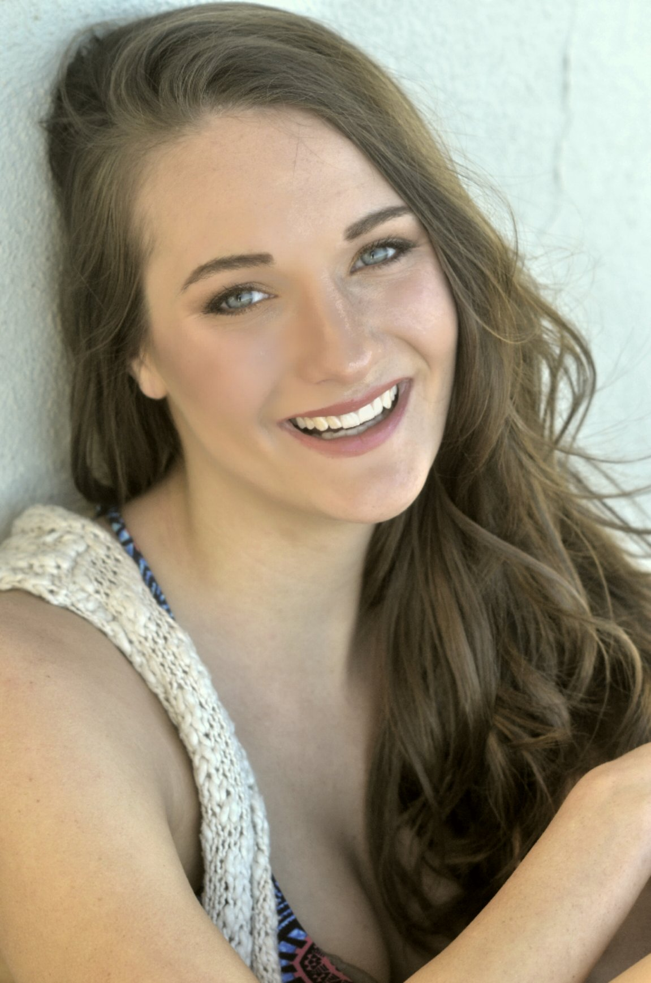
Lydiah Urban
Stats
Height 5’8
Weight 130
Bust 32c
Waist 25
Hip 36
Hair Brown
Eyes Blue
Dress 0
Shoe 7

www.LydiahUrban.com
Lydiahurban@gmail.com
262-210-8836

IG: IttyBittyLiddy93

Work Experience
- Print Work
  - Groupon- Yoga – May 2016
  - Follett- College Book Store July 2015
  - Xfinity- June 2015
  - Landscape Form –March 2015
  - Japonesque Makeup- March 2015
  - Groupon- Eyelashes October 2014
  - VS Chicago Magazine Oct. 2014 & May2015
  - Elda De la Rosa Fashion line campaign 2014
  - Carrissima Salon beauty add
  - Muze Magazine – July 2013
  - Maxim Sac – April 15th , May 13th, May 15th 2013
  - Big St. Charles Magazine – Miss September 2013
  - Patriot Girls –Miss February 2013
  - Ride Hard magazine- 2013

- Tradeshows
  - National Rifle Association - Indiana 2019
  - FIS- Orlando 2019
  - CES- Vegas 2017-2019
  - IMTS- Chicago 2016-2018
  - Green Build Expo- Chicago 2018
  - Rapid- (multi city) 2017-2019
  - CAMEX- San Antonio 2019
  - AM Users Group- Chicago 2017-2019
  - ACC- Chicago 2016
  - Promat- Chicago 2017,2019
  - Home & House Ware Show- Chicago 2016-2019
  - Auto Shows (multi city) 2014-2019
  - National Restaurant Show- Chicago 2015
  - IMTS – Chicago 2015-2018
  - Sweets and Snacks Show – Chicago 2014-2018
  - International Dental show – Chicago 2014
  - Mid American Truck Shows – Louisville 2013
  - International Motorcycle Show- Indiana 2013
- Events
  - Flag Girl-Pirelli- Ohio June 2016
  - Show Girl-Madison, WI 2016
  - NFL Draft – Chicago IL April 2015
  - Ring Girl- Chicago, IL July 2015
  - Fantex Road Show- Chicago, IL February 2014
  - 30 Second Girl – St Louis Missouri, October 2012

- Promotions
  - RAK Week- Feb. 2019
  - Clarins Tour- 2017, 2019
  - Bulls Games- Takis- 2019
  - Spring Break-Fireball and 99 Brand -TX 2019
  - Cubs Games-Budweiser – 2016-2019
  - Spring Rewards Campaign (managed) 2015
  - Groupon Pretty Quick Campaign 2015
  - Riot Fest – Dos Equis- Chicago 2015-2017
  - NFL/GMC Event- Gurnee and St. Louis 2013
  - NASCAR – Goodyear- 2013
  - North Coast Music Festival-Dos Equis- 2013
  - Brickyard 400- Chevy – Indianapolis July 2013
  - Mecum Spring Auction –Chevy 2013
  - Great Drive Sweepstakes – Honda/IZOD/Macys – St Louis May 2013
  - Adobe – Creative Cloud – St Louis, Missouri April, 2013

- Fashion Shows
  - Kitty Chen Couture – Chicago 2016
  - Ursula – Chicago 2015
  - Live Out Loud Fashion – Chicago 2015
  - Midwest Fashion week- March 2014
  - The Dotted Ball – St Louis
- Training
  - Second City Improvisation and Acting
  - Speech and Debate Team- Harper College
  - Dance – Various Academies
  - Singing lesson for 4 years

