Karine Abramyan 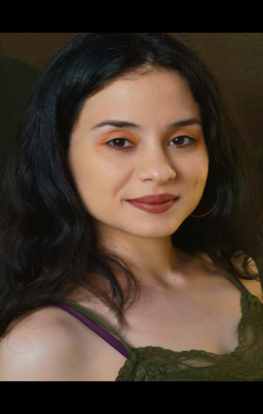

Height: 5’6” (818) 480 - 2296
Hair: Black Eyes: Brown
Special Skills: Modeling, Swimming, Makeup, Voice Animation, Track Running, Singing, Engineering, Painting.
Training: Sanford Meisner Center, Andrew Wood Studios

Films:
Melancholy Corpse Short Film
Fear Grounds Scare Actor Outdoor Event
Catrina Lead Role: Catrina Short Film
Seeking Justice Co-Star: Emily Feature Film
Non-Toxic Co-Star: Tina USC: Student Film
Leap Casting Co-Star: Olivia Short Film
Save U.S. Recurring: Dominatrix Dark Comedy/Drama
Solitude Lead Role: Nancy Indie Film
American Dream Critique Guest Star Music Video
Happyimsad Video Guest Star Music Video
Duty Principal: Hailey Short Film
Mr. Carver Co-Star: Chira Short Film
In Search of Solace Lead Role: Caroline Student Film
The Virtuous Stories Co-Star: Empress-Wife Trilogy
“Leonard: Political Prisoner Voice Over: Native Am. Female Non-Union Podcast
Children Of Elena Co-Star: Vanica Thesis Film
Pimp Co-Star: Latina Detective-Maria Web/TV Series
Fatima Co-Star: Zeinab Short Film

