



Marion
Henley
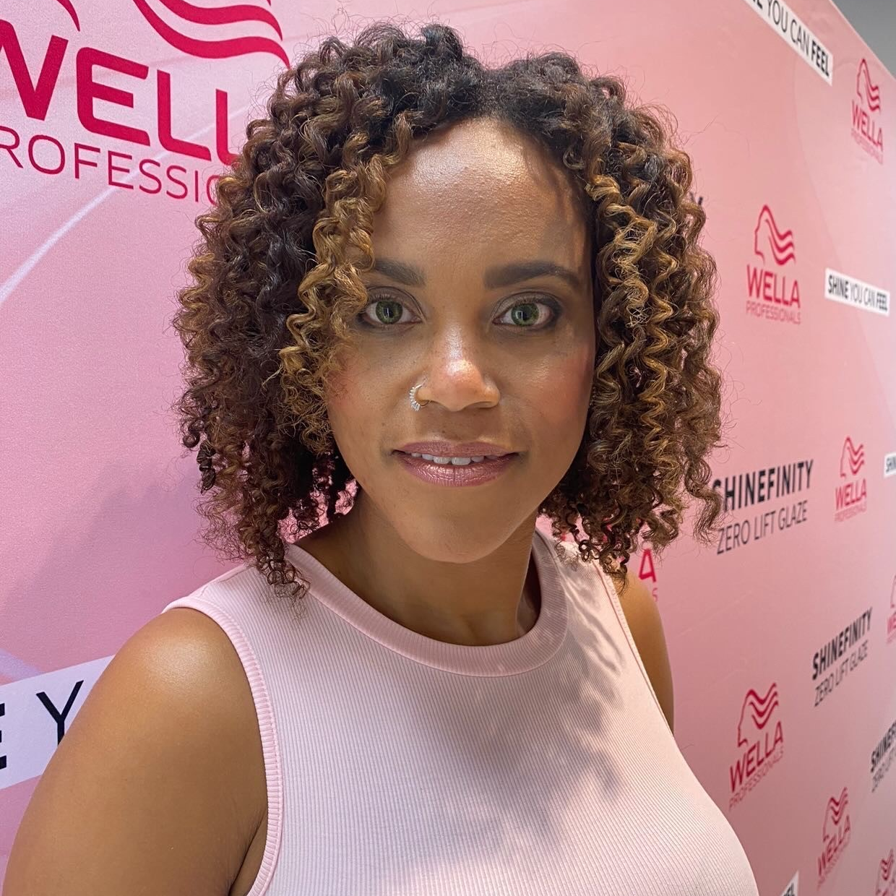 |  | Marion  Henley

Experience
10/23/2022–10/24/2022
Model • Hair Model • Wella Professional
06/11/2022–6/11/2022
Model• Print Model and live Modeling via the website • Fashions by Fowler
01/26/2022–01/26/2022
Model• Print Modeling • Sweet Nothings Boutique
Specializing

Education
Michigan State University, East Lancing, MI
- BA in Political Science Pre Law

Communication
- Lead and presented a Coffee talk with CEO Tricia Griffith on time managements skills
- Lead IT teams as Scrum master during daily stand-up meetings.
- Business systems analyst lead large project communications meeting and project kick offs.

Leadership
Business system analyst in IT I lead the team in and keep us on task during projects kick off meeting and through out the duration of a projects life cycle.
Culture club Networking and communication team lead.
Cheerleading coach for NCT

References
Available upon request.
[Your Address]
[City, ST ZIP Code]
https://www.instagram.com/missone216 

